Peralatan & Hardware yang Direkomendasikan untuk Dry Port
No. | Hardware | Contoh / Model | Spesifikasi Utama | Harga / Unit | Link
1 | 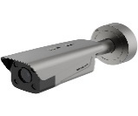  Kamera ANPR Gate | Hikvision DS-TCG406-E / kelas ANPR | Pembacaan plat otomatis, capture kendaraan, outdoor | Rp16 jt | https://www.hikvision.com/id/products/parking-management/vehicle-access-control-management/anpr-cameras/ds-tcg406-e/
2 | 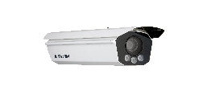  Kamera OCR Kontainer | Hikvision iDS-TCV300-A6I / Container OCR | Membaca nomor kontainer ISO 6346, multi-angle | Rp | https://www.hikvision.com/id/products/ITS-Products/Checkpoint-Systems/Checkpoint-Capture-Units/ids-tcv300-a6i/
3 | 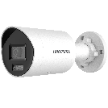  CCTV Yard 4 MP | Hikvision DS-2CD2046G2H-IU | 4 MP, IP67, IR, PoE, monitoring area | Rp3,5 jt | https://www.hikvision.com/en/products/IP-Products/Network-Cameras/Pro-Series-EasyIP-/ds-2cd2046g2h-i-u-/
4 | 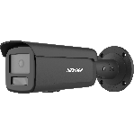  CCTV Yard 8 MP | Hikvision DS-2CD2T87G2H-LI | 8 MP/4K, night vision, outdoor | Rp6,5 jt | https://www.hikvision.com/id/products/IP-Products/Network-Cameras/Pro-Series-EasyIP-/ds-2cd2t87g2h-li/?subName=DS-2CD2T87G2H-LI
5 | 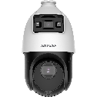  CCTV PTZ | Hikvision DS-2SE4C425MWG-E/14/ TandemVu | Pan-tilt-zoom, monitoring area luas | Rp10,3 jt | https://www.hikvision.com/id/products/IP-Products/PTZ-Cameras/Pro-Series/ds-2se4c425mwg-e-14-f0-/
6 | 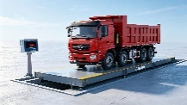  Weighbridge/VGM Scale | Fangda Weighing Apparatus. Electronic Truk Scale | Timbangan kendaraan (Max) 80 t, digital indicator, integrasi komputer | Rp267 jt | https://cnfjkeda.en.made-in-china.com/product/aQRUXTBbvLYe/China-60-Ton-80-Ton-Weighbridge-Price-Electronic-Truck-Scale.html
7 | 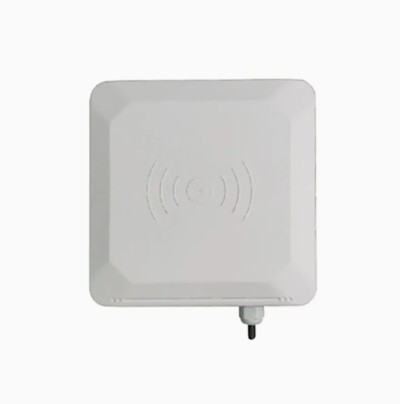  RFID Reader | UHF RFID Reader | Identifikasi kendaraan/kontainer otomatis | Rp3 jt | https://www.orbitadigital.com/en/access-controls/accessories/19689-uhf-reader-20m-access-reader-uhf-tag-access-range-up-to-20-m.html?srsltid=AU7gw4W-9xOfMiyXPAeKZNMOjzHCZE5MXPDDGBDzv9dZqPJhkArSL31rmes
8 | 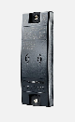  RFID Tag | RFID UHF ID Tag ISO for TRANSIT & ATEX Readers | Identitas kendaraan/kontainer | Rp690 ribu/tag | https://www.ebay.com/itm/316860017458
9 | 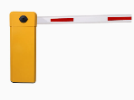  Barrier Gate | Automatic Barrier Gate | Palang otomatis, sensor kendaraan, integrasi ANPR/RFID | Rp60 jt | https://jutaigateopener.en.made-in-china.com/product/MObfpFLKLorl/China-Automatic-Barrier-Gate-with-Single-Bar-Gate-Arm-Barrier-Automatic-Parking-Gate-Barrier.html
10 | 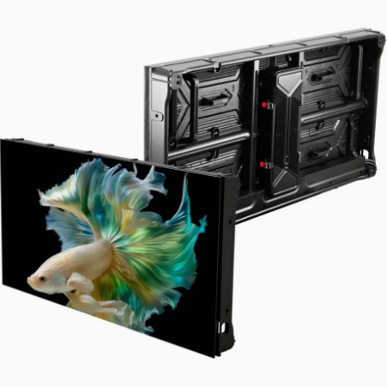  LED Information Display | Outdoor LED Display | Menampilkan nomor gate, instruksi, status kendaraan | Rp47 jt | https://chipshow.en.made-in-china.com/product/KYarZvkHyFhd/China-Sc-Smart-P6-67-Outdoor-LED-Display-for-Wall-Mounted-Advertising.html?ads_tp=&ads_id=KNHThRFckWDX&header_search_page=lv&pv_id=1k34s7p3n352&faw_id=1k34s7ve12f4&bv_id=1k34s7ve2d92&pbv_id=1k34s7np5d62
11 | 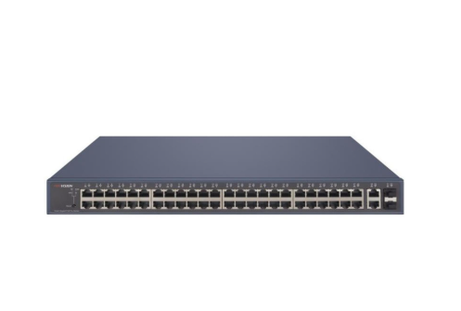  Industrial Network Switch | TP-Link/Hikvision managed switch | Gigabit, VLAN, PoE, koneksi CCTV/IoT | Rp10 jt | https://global.microless.com/product/tp-link-jetstream-48-port-gigabit-l2-managed-switch-with-4-gigabit-sfp-slots-t2600g-52ts-tl-sg3452/?currency=usd&srsltid=AU7gw4Vzb8NkzR3-XRcFkW_MBihLtxXeKKCoSjj3aqHSa5KJbzxyYzsRTi0
12 | 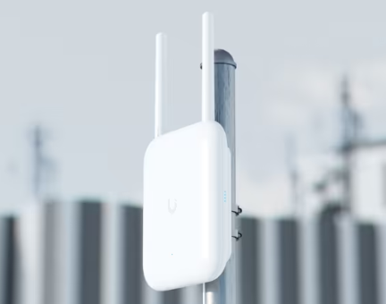  Access Point Outdoor | Ubiquiti U7 Pro / outdoor AP | Wi-Fi berkecepatan tinggi untuk area operasional | Rp7,2 jt | https://www.aloinfousa.com/products/ubiquiti-networks-unifi-u7-pro-outdoor-tri-band-wi-fi-7-access-point?currency=USD&country=US&utm_source=google&utm_medium=cpc&utm_campaign=Google%20Shopping&stkn=e9174bb7751a&gad_source=1&gad_campaignid=23457598037&gbraid=0AAAAAoyrHIfZOv7HdfZ_iRDKbvZrUliAv&gclid=Cj0KCQjwzsjVBhC3ARIsALnMv4ldyj-T512n1M9kBIdQaq-C_mEv5-vo5tc2ph5QDCwJRV7YOwGZBHIaArQMEALw_wcB
13 | 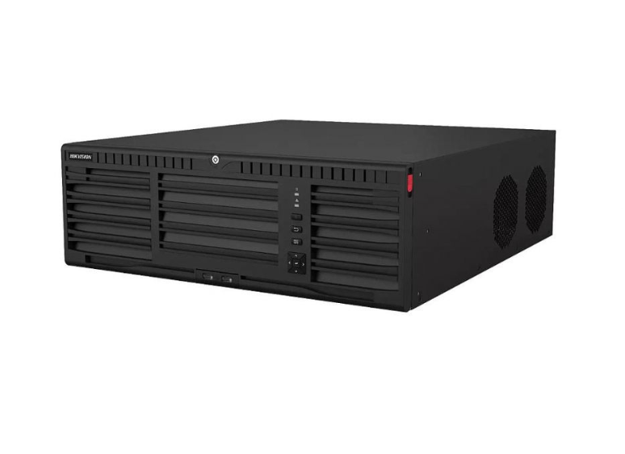  Server/NVR | Hikvision olutions DS-9664NI-M16/R – Hikvision NVR / rack server | Rekaman CCTV, database, integrasi aplikasi | Rp102 jt | https://www.orbitadigital.com/en/cctv-ip/ip-nvr-recorders/56602-hikvision-solutions-ds-9664ni-m16-r-hikvision-nvr-recorder-64-ch-ip-solutions-maximum.html?srsltid=AU7gw4V__qr6N77TSSoz9hqyMui8XKZRRsIqadp3X2YPLvelzwYKNIjESdg
14 | 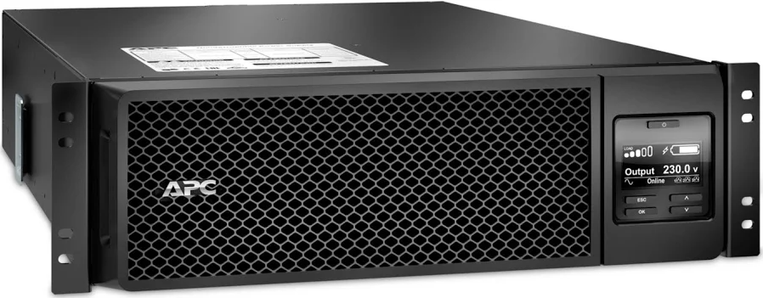  UPS | APC SRT5KRMXLI Smart-UPS SRT 5000VA RM 230V | Backup listrik perangkat jaringan/server | Rp81 jt | https://www.monotaro.id/items/s013485894.html?utm_source=google&utm_medium=pla&utm_campaign=23518660777&utm_content=192662639019&utm_term=others_cat_group_3_pricebrand_group_2_existing&gad_source=1&gad_campaignid=23518660777&gbraid=0AAAAADJU9-_ezfHJPtEZorai3rN2zdtQP&gclid=Cj0KCQjwzsjVBhC3ARIsALnMv4lo4zw3aRtHA34KSYTO9i8qBvvYOlE8p9xtppJGOxCSwgLHwF8NqXwaAmWqEALw_wcB
15 | 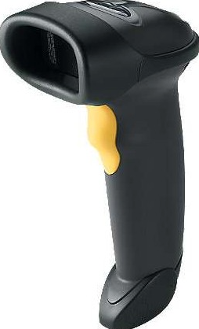  Barcode/QR Scanner | Zebra Symbol LS2208 / Honeywell | Scan dokumen, gate pass, container ID | Rp1,6 jt | https://www.monotaro.id/items/s003425886.html?utm_source=google&utm_medium=pla&utm_campaign=23514026828&utm_content=192362859573&utm_term=others_cat_group_1_pricebrand_group_2_existing&gad_source=1&gad_campaignid=23514026828&gbraid=0AAAAADJU9-9qcoYXHXK5gtekEzHMXf7IX&gclid=Cj0KCQjwzsjVBhC3ARIsALnMv4lgHRQqcj5LIgsmS-jtiHFbRis1oxWSLkDcuschM9F4fuDWhFjDs9YaAtkfEALw_wcB
16 | 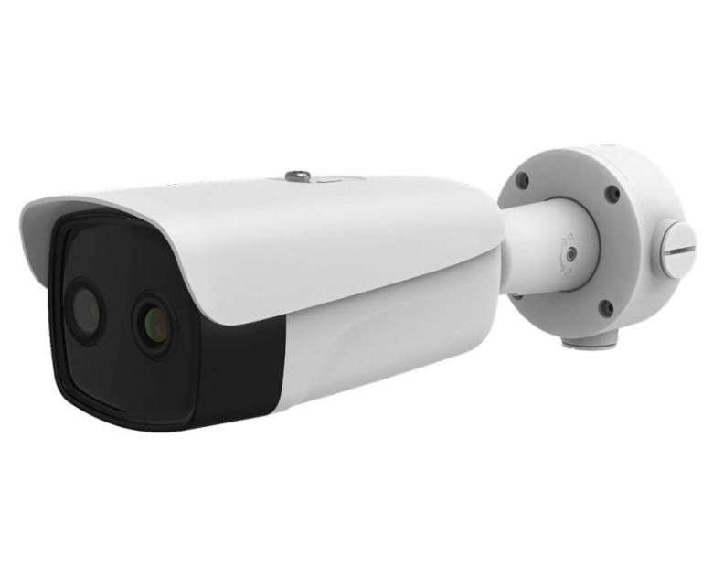  Thermal Camera Reefer | Hikvision DS-2TD2636B-13/P Thermal | Monitoring suhu/area reefer dan deteksi abnormalitas | Rp30 jt | https://www.hikvision.com/mena-en/products/Thermal-Products/Thermography-thermal-cameras/temperature-sceening-series/
17 | 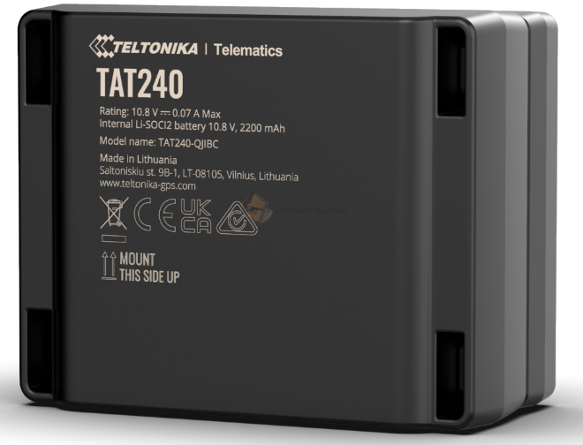  GPS Tracker Truck | TAT 240 4G TELTONIKA GPS TRACKER | Posisi kendaraan real-time, tracking perjalanan | Rp2,5 jt/unit | https://www.slapukas.lt/ee/teltonika-tat240
18 | 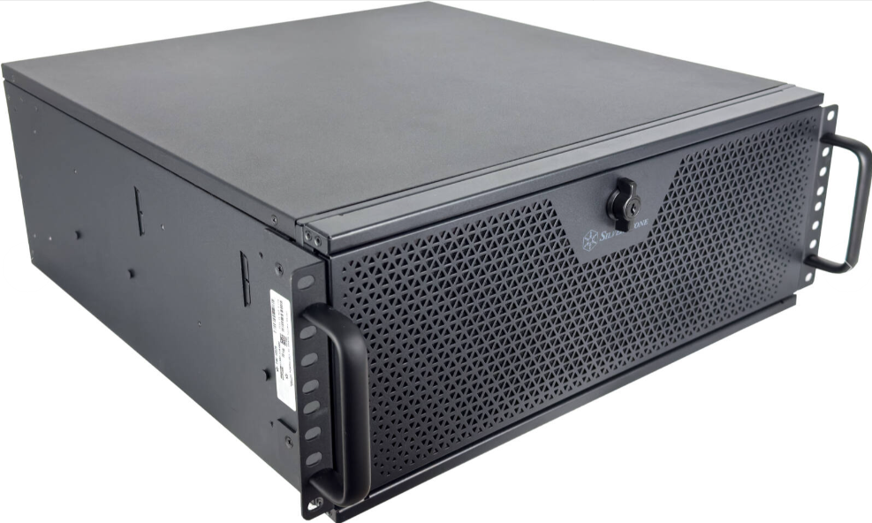  Industrial PC/Edge Computer | Intel Industrial PC | Memproses OCR/ANPR/IoT di lapangan | Rp120 jt | https://global.microless.com/product/rackmounted-workstation-intel-core-i9-14900kf-24-cores-32-threads-nvidia-rtx-pro-4000-blackwell-24gb-32gb-ram-ddr5-6000mhz-4tb-ssd-gen4-1200w-80-plus-gold-psu-360mm-liquid-cooler-win11-pro/
19 | 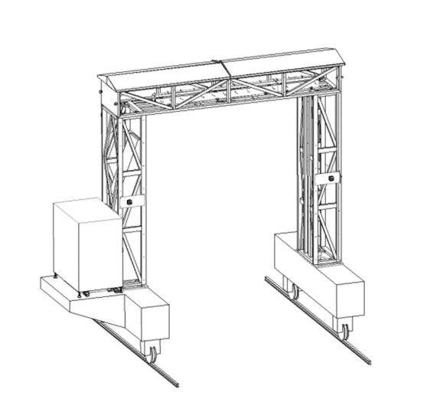  Kontainer X Ray | Custom model | sistem penyaringan keamanan barang / Peti kemas | Rp | Sistem Inspeksi Kontainer X Ray Kendaraan untuk Memeriksa Bom di Van Bea Cukai, Pelabuhan - Cina Sistem Inspeksi kendaraan, Alat berat sinar-X
20 | 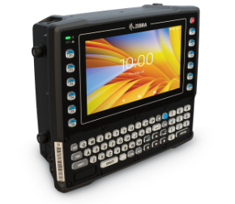  Vehicle Mounted Terminal | Vehicle Mounted Terminal (VMT)Zebra VC8300 | membantu mengatur inventaris / peti kemas dan mempercepat proses logistik. | Rp74 jt | https://www.zebra.com/ap/en/products/mobile-computers/vehicle-mounted/vc8300/vc8300.html

